15.07 Picture Lab Worksheet
Directions: Make note of your responses to the following questions as you work through the activities and exercise in the lesson.
Activity 5 Questions
Question | Yes | No
- Is the method getPixels2D in the Picture.java class? |  | No. It is, however, inherited from the SimplePicture class
- Is the method getPixels2D in the SimplePicture.java class? | Yes
- Will the following code compile?  DigitalPicture p = new DigitalPicture(); |  | No. Digital picture is an abstract framework
- Assuming a no-argument constructor exists for SimplePicture, will the following code compile?  DigitalPicture p = new SimplePicture(); | Yes, it will compile fine
- Assuming a no-argument constructor exists for Picture, will the following code compile?  DigitalPicture p = new Picture(); | Yes
- Assuming a no-argument constructor exists for Picture, will the following code compile?  SimplePicture p = new Picture(); | Yes
- Assuming a no-argument constructor exists for SimplePicture, will the following code compile?  Picture p = new SimplePicture(); |  | Nope

Activity 5 Exercise Results

- Describe your method for keepOnly red, blue, or green.
My method for keepOnlyBlue gets the pixels of the the picture, and loops through the 2D array. For each pixel, it calls the setRed(0) and setGreen(0) methods so only blue remains.

public void keepOnlyBlue() {
Pixel[][] pixels = this.getPixels2D();
for (Pixel[] rowArray : pixels) {
for (Pixel pixelObj : rowArray) {
pixelObj.setRed(0);
pixelObj.setGreen(0);
}
}
}

- For the negate method, paste your code related to calculating and setting the values for red, blue, and green.
For the negate method, I looped through all the pixels for the image and set each pixels color to 255 – (current color).

public static void testNegate() {
Picture beach = new Picture("beach.jpg");
beach.explore();
beach.negate();
beach.explore();
}

- Paste a copy of the image that is the result of calling the grayscale.
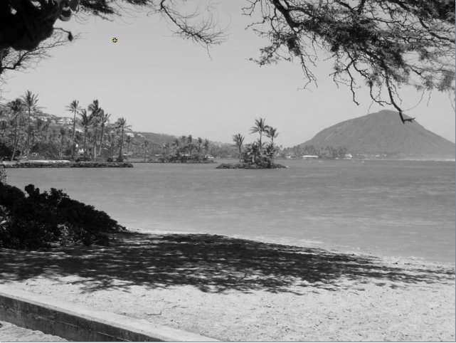
- For the method fixUnderwater, describe the algorithm you'd propose to accomplish the task.

Activity 6 Exercise Results
- Paste the image that is the result of calling the method mirrorVerticalRightToLeft

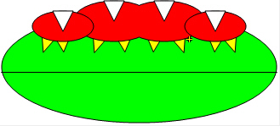
- Describe the algorithm for the method mirrorHorizontal works.

mirrorHorizontal works by looping through each column of pixels in the image. For each column, you loop through each row (pixel) in that column. For each pixel, you set it’s color to the mirror of that pixel.
- Paste the image that is the result of calling the method mirrorHorizontalBotToTop.

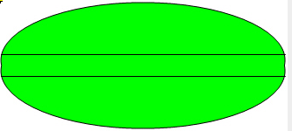

Activity 7 Questions
  - How many times would the body of this nested for loop execute? 90
for(int row = 7; row < 17; row++)
for(int col = 6; col < 15; col++)
  - How many times would the body of this nested for loop execute? 112
for(int row = 5; row <= 11; row++)
for(int col = 3; col <= 18; col++)

Activity 7 Exercise Results

- What value is displayed for count after the nested loop ends in the mirrorTemple method? 18410
- Paste the image that is the result of calling the method mirrorArms.
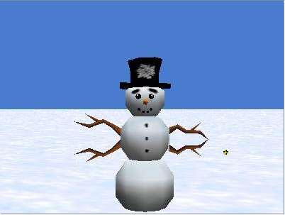

- Paste the image that is the result of calling the method mirrorGull.
